FPS at 70

In 2023, Finchley Progressive Synagogue turns seventy. Seventy years of infusing North London life with meaning. Happy birthday to us!

We are a unique and special synagogue community in Finchley who, over these past 7 decades, have tried to bring thoughtful meaning, welcome and inclusion to all those who come through our doors. ‘Come as you are’’ we say to our members. Being at home here is critical and belonging as important as much as believing.

We make meaning for individuals as they mark moments in their lives and we enable soulful encounters and sacred relationships that grow here in our synagogue. We are a force for good in the wider community and beyond. With audacious hope and enthusiastic energy, we make a difference.

FPS has a growing and diverse community. With a vibrant Jewish life, with the strong values of Tikkun Olam, Mending the world. We are a community who takes responsibility for each other and the world we live in.
This is our anniversary year and it is time to care for our building that has housed us well but needs some love, care and attention. We want to remain open and attractive to all for another 70 years.
Our commitment to making a difference

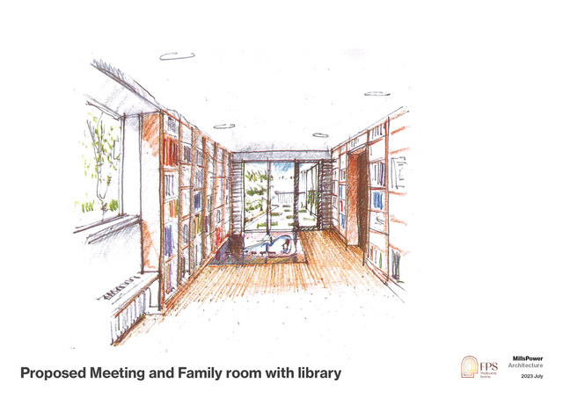
Finchley Progressive Synagogue is not just a place of worship, it is a significant resource to various groups in the wider community, supporting the homeless, refugees, families and the elderly. We are in the midst of organising mental health support sessions for the young people and children of asylum seekers who are living in hotels (offering activities such as homework club/youth club/a space to feel safe outside of their rooms). Leading the borough on settling Syrian refugees in 2015 strengthened our commitment to doing work as Jews in the local area, from hosting winter shelters, to refugee drop ins, to supporting other local charities. Building on the value of everyone being created, B’tzelem Elohim, in the image of God, all deserving of dignity.

We have a leaking roof, draughty windows, an outdated heating system and antiquated bathroom facilities. Lovingly sustained by members over the last 65 years or so, our building now needs some more robust and structural attention. We have developed a plan to:

- Repair and replace our sanctuary roof (we aim to create spiritual uplift in our sanctuary)
- Update our bathrooms and create fully accessible washrooms.
- We must enable a safer division and fulfil the safeguarding needs of Southover Partnership School who are our valued tenants.
- Ensure a warm community room to be used by all.
- Spruce up the entrance to the shul to raise morale and pride in our congregation.
- Maintain and restore our wooden floors and original doors
- Install more sustainable heating
- Install solar panels and insulation

We have already raised over £500,000 of a £1m goal. We hope you might consider giving to our appeal and we attach a pledge form.

Building fund pledge form

